# Spring boot with SFTP

1. What we going to use to connect sftp server is JSch check this out >>  
   <https://mvnrepository.com/artifact/com.jcraft/jsch>
2. Add JSch into your pom.xml (please check version in link above)

<dependency>

<groupId>com.jcraft</groupId>

<artifactId>jsch</artifactId>

<version>0.1.54</version>

</dependency>

1. Now you can use JSch to connect and get, put file as you want.
2. Now let start some coding in this example I’m going to code and run in test case.
3. Prepare your credential.  
   - host, user, pass, port is required.  
   - encoding type if need***  
   - channel will be used to select channel.  
   - workingDir if need***  
   - filename you want to get from sftp server.  
   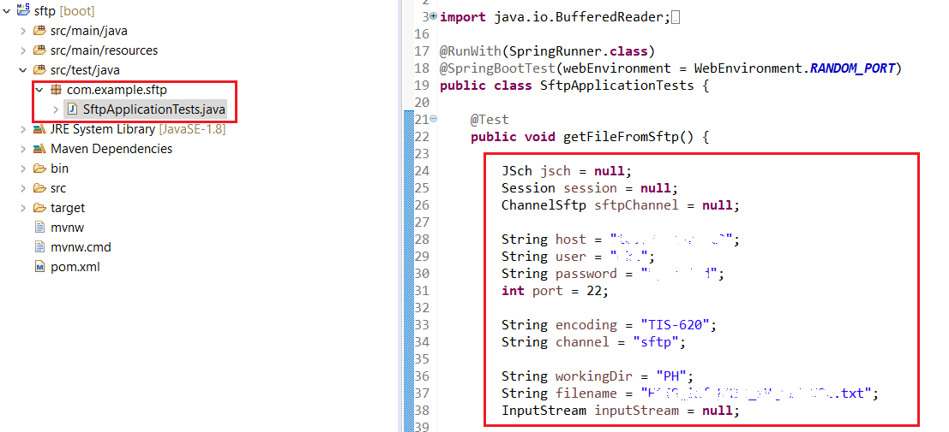
4. This is simple code how to get data from sftp server.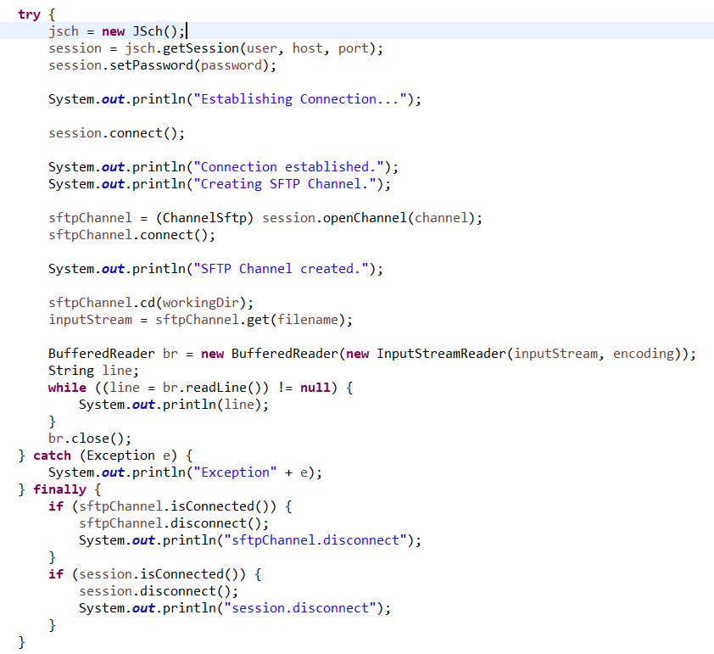  
   but if you run it you might encounter an error like picture below :  
   check this out >> <https://stackoverflow.com/questions/2003419/com-jcraft-jsch-jschexception-unknownhostkey>  
     
     
   to get through this error in testing you need to set configuration as picture below:   
   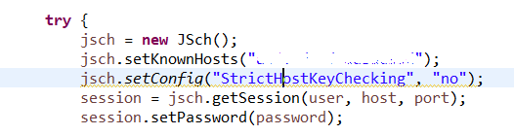  
     
   but for production usage you need to used **jsch.setKnownHost** instead.
5. Now you can go through error and get data from file already as picture below:  
    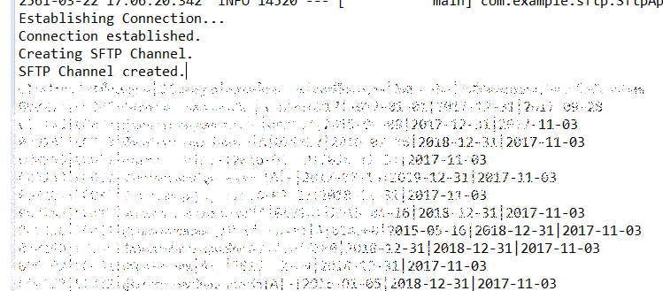
6. Now in reverse if you want to put file to server this how to do.  
   code is the same as get file but what you need to change is add new File and put it to server as picture below:  
   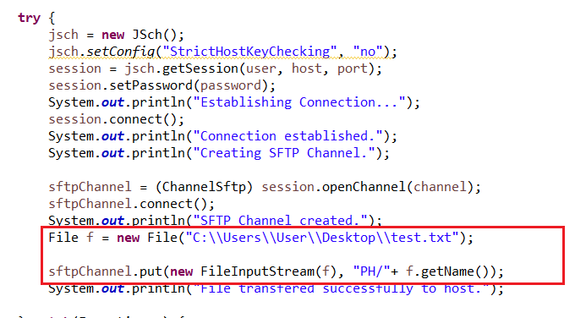
7. Once you run test case it going to upload file from your local pc to server and check the result as below:  
   